Solr search engine is one of the commonly used search platforms worldwide.
Solr(pronounced as "solar") is an enterprise-ready, fast and highly scalable, open source search engine built on a Java library called Lucene
SOLR is abbreviated as "Searching On Lucene w/Replication"

Here is an overview of the list of topics that you will be learning in this course.
- Introduction to Solr
- Solr Architecture
- Documents and schema design
- Solr Installation
- Solr Core
- Solr Indexing
- Analyzers, Tokenizers and Filters
- Searching in Solr

- 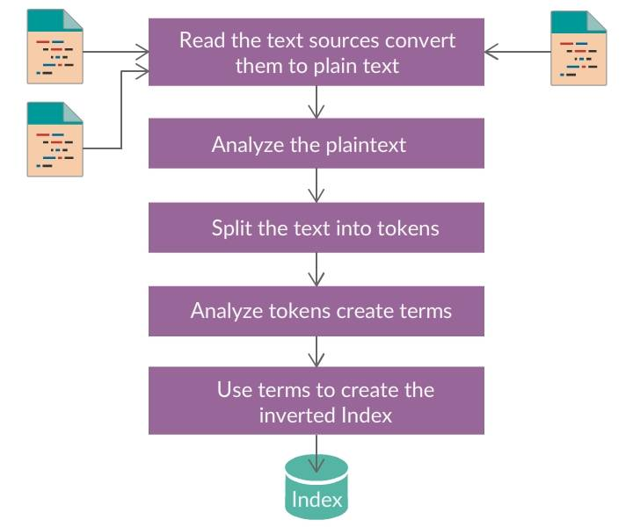

Quick Fact
Solr was designed by Yonik Seeley in the year 2004 to add search capabilities to the company website of CNET Networks.

History of Solr
- In January 2006, Solr was made an open source project under the Apache software foundation. This helped to solve legal, financial and organizational issues.
- In January 2009, Solr joined the Lucidworks (first company to provide economic support and training for Solr search technologies)
- In March 2010, Lucene and Solr projects were combined. Solr became a sub-project of Lucene.
- In 2011, the Solr version number was changed from Solr 1.4 to Solr 3.1, to keep the same version number for Solr and Lucene.
- Solr 4.0 (improved reliability) , Solr 5.0 (packaged as a standalone application), Solr 6.0(parallel SQL query execution over SolrCloud collections)
- In September 2017, Solr version 7.0 was released. This version supports many replica types, a Math engine, and auto-scaling.
Use Case:
If you have millions of articles, you run code to scan these articles and add the required information to the inverted index(Solr index). When you search for information using keywords, Solr will search in its index and return the documents that match with the user’s query.
In Solr, inverted index is created using Lucene classes.

Some of the features of Solr include:
- Advanced full-text search capabilities.
- Extensible Plugin Architecture.
- Optimized for high volume traffic.
- Faceted search and filtering.
- Easy monitoring.
- Geospatial search.
- Multiple search indices.
- Rich in document parsing.
- Highly scalable and fault tolerant.

Benefits of Solr
- Performance Improvements: Text comparison is very faster in Solr because it is particularly written for indexing, full-text searching and comparing results.
- Faceting: The ability to classify the content based on the distinct properties is known as Faceting.
- Complex Weighting: Solr has the ability to get the results at the time of indexing as well as at the time of searching, based on various parameters.
- Smart Searching: Solr can handle homophones, misspellings, and search using latitude/longitude coordinates. Hence, Solr can be used for any type of specific search.
Ex: http://qa-kssolr-lx01.amdc.mckinsey.com:8983/solr/document_dictionary/spell?indent=true&spellcheck.collate=true&spellcheck=true&wt=json&spellcheck.q=maket
http://localhost:8983/solr/document_dictionary/spell?indent=true&spellcheck.collate=true&spellcheck=true&wt=json&spellcheck.q=pssble

The following are few of the popular clients using Solr in their applications.
- NASA uses Solr as the Enterprise Search component in its NEBULA cloud computing platform.
- Flipkart is using Solr to power e-commerce search over its huge catalog.
- Instagram a Facebook company, uses Solr to power it's geo-search API.
- Kalender.se is using Solr for searching the events and calendar autocompletion.
- MacMall is using Solr for searching and faceted browsing.

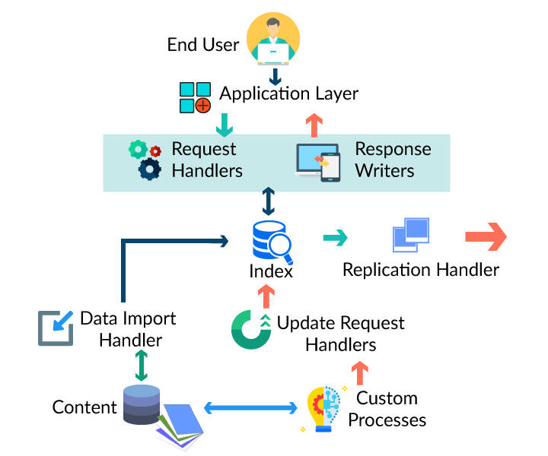

Request Handler:
- Process the Solr requests.
- A request can be either an update request or query request.
- Selected based on your environment.

Response Writer:
- Generates the formatted outputs for user queries.
- Supports the formats like CSV, XML, and JSON.

Facets and components:
- Classify the searched results into many categories.
Index searcher:
- Searches with a default base searcher class that returns the matched results of the searched keyword in an ordered manner.
Query Parser:
- Parses the queries and verifies them for syntactical errors.
- Parsed queries are translated to the Lucene understandable format by Query Parser.
Index Writer:
- Creates and maintains the indexes in Apache Lucene.
Index Reader:
- Provides access to the indexes stored in a file system.
Analyzers and Tokenizers:
- The data is recognized in the form of tokens by Lucene.
- The text in fields are examined, and the Analyzer generates a token stream.
- The tokenizer breaks down the token stream into tokens.
- 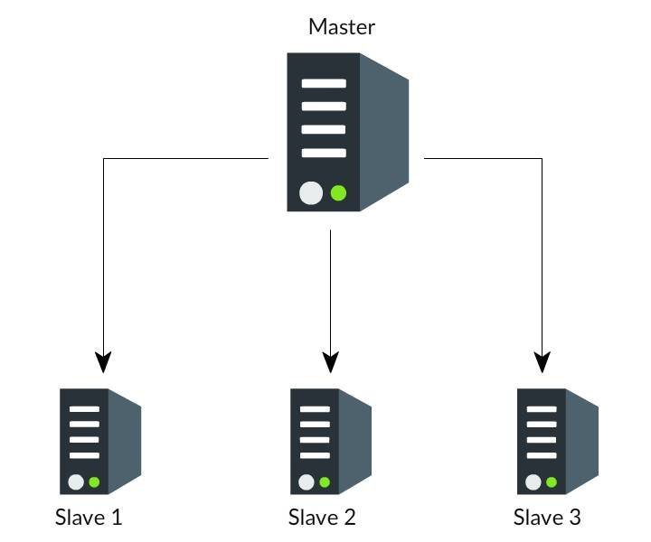

When Solr runs in a master-slave mode
- The entire copies of a master index are distributed to one or more slave servers by Index Replicator.
- A master server maintains the index updations, and a slave server maintains the queries.
- 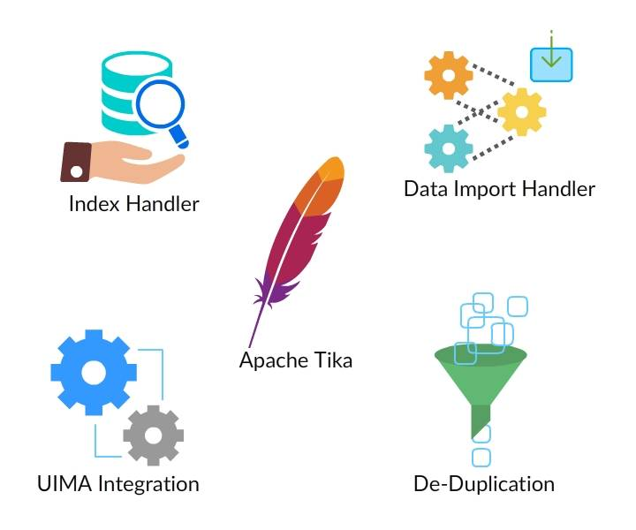

Index Handler:
- Handles the tasks like adding, deleting and updating documents for indexing.
De-Duplication:
- Prevents the duplicate documents from entering into the Solr index.
Data Import Handler:
- Provides a procedure for combining various data sources with Solr for indexing.
UIMA Integration:
- Defines custom pipelines to add metadata to documents.
Apache Tika:
- Detects and extracts text and metadata from many files of different types.

Common Terminologies
It is better to understand the meaning of some of the below jargons while working on Solr.
- Instance: Points to the application server that runs insides a JVM. The base directory of Solr gives a reference to every Solr instance, where one or more cores are configured to run each instance.
- Core: It is known as a running instance of a Lucene index which includes the whole Solr configuration files required to use it.
- Home: The word $SOLR_HOME is referred to as the home directory which contains the information about the cores and their indexes, dependencies, and configurations.
- Shard: In the distributed environment, the information is divided among the multiple Solr instances, where each part of data is called as Shard.
- 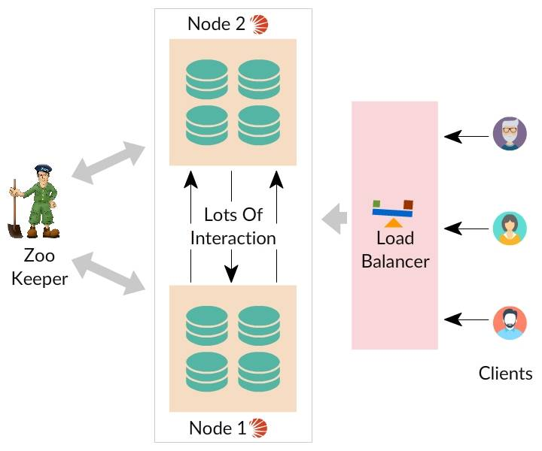

SolrCloud is created to implement a highly accessible and fault tolerant environment for distributing the indexed content and query requests over many servers. SolrCloud automates many tasks with the help of Zookeeper.
The following are some of the features provided by SolrCloud.
- Central configuration for the complete cluster.
- Automatic load balancing and fail-over for queries.
- ZooKeeper integration for cluster coordination and configuration.

Documents
In Solr, data is rendered in the form of documents, which is the unit of index and search in Solr. Solr index can have multiple documents, and each document consists of one or more fields.

Schema
Solr schema contains all the information related to field types. It has to be specified in a file called schema.xml, before adding the documents. The schema cannot be changed once the documents are added to Solr index.

FieldTypes
The following are some of the basic field types available in Solr.
- long
- double
- float
- date
- text

The following are the configuration files of Solr.
- solrconfig.xml
- solr.xml
- core.properties
- schema.xml

solrconfig.xml
solrconfig.xml file defines
- How requests are managed and
- How to manipulate data to the user.
Following are the commonly used elements in the solrconfig.xml
- Data directory location
- Cache parameters
- Request Handlers
- Search components

solr.xml file
solr.xml file
- Contains information related to SolrCloud
- Includes mappings for request URLs
- Identify the core
The sample solr.xml file is shown below.
Example:
<?xml version='1.0' encoding='UTF-8'?>
<solr persistent="true">
<cores adminPath="/admin/cores">
<core name="Default" instanceDir="default"/>
<core name="MC_10001_CatalogEntry_Unstructured_en_US" instanceDir="MC_10001_\en_US\CatalogEntry\unstructured"/>
<core name="MC_10001_CatalogEntry_en_US" instanceDir="MC_10001_\en_US\CatalogEntry"/>
<core name="MC_10001_CatalogGroup_en_US" instanceDir="MC_10001_\en_US\CatalogGroup"/>
</cores>
</solr>

core.properties file
core.properties: core.properties is a simple java properties file where each line in a file looks like a key=value pair. It defines the specific properties for a core like
- Name of the core
- Collection the core belongs to
- schema location etc.

schema.xml file
schema.xml contains the information about
- Solr fields and
- How the fields are analyzed and filtered during searches.
The sample schema.xml code is shown below.
Example:
<fieldType name="wc_text" class="solr.TextField" positionIncrementGap="110">
<analyzer type="index">
<tokenizer class="solr.WhitespaceTokenizerFactory"/>
<filter class="solr.StopFilterFactory" ignoreCase="true" words="stopwords.txt" enablePositionIncrements="true" />
<filter class="solr.WordDelimiterFilterFactory" generateWordParts="1" generateNumberParts="1"
catenateWords="1" catenateNumbers="1" catenateAll="0" splitOnCaseChange="0" preserveOriginal="1"/>
<filter class="solr.LowerCaseFilterFactory"/>
<filter class="solr.SnowballPorterFilterFactory" language="English" protected="protwords.txt" />
<filter class="solr.RemoveDuplicatesTokenFilterFactory"/>
</analyzer>
</fieldType>

Requirements for Solr Installation
Solr (7.4.0) is the current latest version.
- To install Solr 7.4.0, you need to have Java 8 or above version installed on your system.
- You can check for the Java version installed on your system by executing the below command.
java -version
- Make sure that your machine meets the Java requirements of Solr.

Solr Installation on Ubuntu
- The required Solr version can be downloaded from its official site. You can also download Solr 7.4.0 by executing the following command.
sudo wget http://www-eu.apache.org/dist/lucene/solr/7.4.0/solr-7.4.0.tgz
- The Solr service installer shell script is extracted from the downloaded Solr archive file. The following command is used to run the installer.
tar xzf solr-7.4.0.tgz solr-7.4.0/bin/install_solr_service.sh --strip-components=2
sudo bash ./install_solr_service.sh solr-7.4.0.tgz
- Now the Solr is installed on your system. You can check the status by executing the following command.
sudo service solr status

Access Solr Admin Panel
The default port for Solr is 8983.
The following link helps you to access Solr port in your browser where you will get the Solr dashboard.
https://hostname:8983/

Solr Installation On Windows Environment
After downloading the Solr file and extracting it on C drive, you can use the following command to start the Solr.
C:\>cd solr-7.4.0/bin
C:\solr-7.4.0\bin>solr start
The Solr Installation can be verified by accessing the following link in the browser.
http://localhost:8983/
You will see the Apache Solr User interface dashboard, once the installation is successful.
Solr Core is a running instance of a Lucene index which includes the whole configuration files required to use it. To perform indexing and searching operations, you need to create a core.
A Solr application can have one or multiple cores.
After installing Solr on your system, you need to connect to the Web Interface of Solr to create Solr Core.

Creating Solr Core
Using Create Command: A schema-less core can be created by using the Create Command. This can be created by executing the following command.
sudo su - solr -c "/opt/solr/bin/solr create -c <core_name> -n data_driven_schema_configs"
Example:
sudo su - solr -c "/opt/solr/bin/solr create -c mycollection -n data_driven_schema_configs"
Using create_core command: The create_core command has the following options.
- -c core_name: describes the name of the core that you want to create
- -p port_name: port at which you want to create a core
- -d conf_dir: configuration directory of the port
Syntax:
sudo su - solr -c "/opt/solr/bin/solr create_core -c <core_name> -n data_driven_schema_configs"

Deleting Solr Core
You can also delete the cores, that is created earlier.
First you need to go to bin directory and then execute the following command.
./solr delete -c <core_name>
For example, if you want to delete the core with a name my_solrcore, out of the two cores my_solrcore and my_solrcore1, you need to execute the below command.
./solr delete -c my_solrcore

Solr Indexing
The arrangement of documents in an ordered manner is commonly known as indexing. It enables the user to get the information from a document.
- Indexing collects the data, parses it and stores the documents.
- Indexing is performed to improve the speed and performance of a search query while getting a required document.
In Solr, the content has to be added to the inverted index to make it searchable by Solr. Solr index accepts data from various sources, including CSV files, XML files and the files which are in the common format such as Microsoft Word or PDF.
Indexing in Solr is done by using various interfaces like the
- command line,
- web interface and
- Java client API.

Adding Documents Using Solr Web Interface
Let us see how to add the following JSON format document to the Solr Core by using the Solr Web Interface.
[
{
"id" : "001",
"name" : "Ramu",
"age" : 56,
"Designation" : "Senior Manager",
"Location" : "Chennai",
},
{
"id" : "002",
"name" : "Robert Watson",
"age" : 49,
"Designation" : "Senior Programmer",
"Location" : "Hyderabad",
}
]

Adding Documents Using Solr Web Interface
Step 1: Open the Solr Admin Interface by accessing the below link:
http://localhost:8983/
Step 2: Select the Solr Core and click document option to add the documents.
Step 3: Choose the format of the document to be indexed.
Step 4: Type the document text in the text field.
Step 5: Finally click on Submit button.

Adding Documents Using Java Client API
The following steps help you to write Java code for adding documents.
- Prepare the Solr client
String urlString = "http://localhost:8983/Solr/<core_name>";
SolrClient Solr = new HttpSolrClient.Builder(urlString).build();
- Prepare the Solr document
SolrInputDocument doc = new SolrInputDocument();
- Add fields to the document
doc.addField("id", "009");
doc.addField("name", "Tom");
doc.addField("age","90");
doc.addField("addr","Banglore");
- Add the document to Solr
Solr.add(doc);
- Save the changes
Solr.commit();
System.out.println("Documents added");

Adding Documents Using Post Command
Solr features a post command in its bin/ directory. Hence, move the file to be indexed into the bin directory before indexing it using the post command.
Let us consider the below XML code and assume that the file is saved with the name sampleadd.xml.
<add>
<doc>
<field name = "id">001</field>
<field name = "first name">Ramu</field>
<field name = "last name">Chowdary</field>
<field name = "phone">9812365495</field>
<field name = "city">Chennai</field>
</doc>
</add>
The above XML file can be added using the post tool, by executing the following command.
./post -c <Core_Name> <file_name>

Updating Documents Using Post Command
The following XML file helps you to update a field in the existing document.
<add>
<doc>
<field name = "id">001</field>
<field name = "first name" update = "set">Rajshekar</field>
<field name = "last name" update = "add">Chava</field>
<field name = "phone" update = "add">9956321472</field>
<field name = "city" update = "add">Pune</field>
</doc>
</add>
The fields in the documents can be updated by executing the following command.
./post -c <core_name> <file_name>

Updating Document Using Java Client API
The following steps help you to build a Java code to update the documents.
- Prepare the Solr Client
String urlString = "http://localhost:8983/Solr/my_core";
SolrClient Solr = new HttpSolrClient.Builder(urlString).build();
- Prepare the Solr document
SolrInputDocument doc = new SolrInputDocument();

UpdateRequest updateRequest = new UpdateRequest();
updateRequest.setAction( UpdateRequest.ACTION.COMMIT, false, false);
SolrInputDocument myDocumentInstantlycommited = new SolrInputDocument();

myDocumentInstantlycommited.addField("id", "002");
myDocumentInstantlycommited.addField("name", "Rahul");
myDocumentInstantlycommited.addField("age","47");
myDocumentInstantlycommited.addField("address","Chennai");

- Update the documents
updateRequest.add( myDocumentInstantlycommited);
- Save the Changes
UpdateResponse rsp = updateRequest.process(Solr);
System.out.println("Documents Updated");

Deleting Documents from Solr Index
Documents can be deleted from the Solr Index by specifying the document ids between the <delete> and </delete> tags.
For Example:
<delete>
<id>003</id>
<id>005</id>
<id>004</id>
<id>002</id>
</delete>
The documents with the ids mentioned in the XML code are deleted by executing the following post command.
./post -c <core_name> <file_name>

Deleting a Field Using Post Command
Sometimes you need to delete a document based on the field rather than id. In that case, you need to define the name and the value of the field within <query> and </query> tags.
Syntax:
<delete>
<query>name:value</query>
</delete>
Once the code is ready, you need to execute the following post command to delete a field.
./post -c <core_name> <file_name>

Deleting All Documents Using Post command
If you want to delete all the documents in the index, you have to pass the symbol ":" between the two tags <query> and </query>.
Syntax:
<delete>
<query>*:*</query>
</delete>
Documents are deleted by executing the following command.
./post -c <core_name> <file_name>

Deleting Documents Using Java Client API
The following Java code helps you to delete the documents from the Apache Solr Index.
- Prepare the Solr client
String urlString = "http://localhost:8983/Solr/<core_name>";
SolrClient Solr = new HttpSolrClient.Builder(urlString).build();
- Prepare the Solr document
SolrInputDocument doc = new SolrInputDocument();
- Delete the documents from Solr
Solr.deleteByQuery("*");
- Save the document
Solr.commit();
System.out.println("Documents deleted");

To search effectively and efficiently, Solr breaks the data into tokens, during indexing and querying. It does this using the following three main components.
- Analyzers: Examine the field data and generate the token stream.
- Tokenizers: Break the field data into tokens
- Filters: Responsible for examining the token stream and does the filtering job like keeping the tokens or discarding them or creating a new token
Tokenizers and filters are placed side by side such that the output of one is the input to the other. This sequence of tokenizer and filter is known as Analyzer, whose output is used for indexing and querying.

Analyzers
Analyzers are used for preprocessing the text during indexing as well as querying.
- The easiest way to configure an analyzer is with a single <analyzer> element.Example:
<fieldType name="nametext" class="solr.TextField">
<analyzer class="org.apache.lucene.analysis.core.WhitespaceAnalyzer"/>
</fieldType>
- The other way is to perform the complex analysis on the input text content. This can be done by simply specifying the <analyzer> element followed by the child elements(tokenizers and filters).
Example:
<fieldType name="nametext" class="solr.TextField">
<analyzer>
<tokenizer class="solr.StandardTokenizerFactory"/>
<filter class="solr.StandardFilterFactory"/>
</analyzer>
</fieldType>

Analysis Phases
Analysis occurs during indexing as well as querying.
- At index time (field is being created), the token stream that is generated from the analysis is added to the index and the terms like position, size, etc. are defined for a field.
- At query time, the queries are analyzed and are matched to those terms that are present in the index.
Example:
</fieldType>
<fieldType name="nametext" class="solr.TextField">
<analyzer type="index">
<tokenizer class="solr.StandardTokenizerFactory"/>
<filter class="solr.LowerCaseFilterFactory"/>
</analyzer>

<analyzer type="query">
<tokenizer class="solr.StandardTokenizerFactory"/>
<filter class="solr.LowerCaseFilterFactory"/>
</analyzer>
</fieldType>

Analysis for Multi-Term Expansion
In some of the queries like Wildcard, Regex, Prefix, etc. the user input is not a natural language designed for analysis.
- The stop word filter, synonyms may not work logically, in these type of queries.
- The analysis factories that work with these queries are known as MultiTermAwareComponents.
Example:
<analyzer type="multiterm">
<tokenizer class="solr.KeywordTokenizerFactory"/>
</analyzer>

Tokenizer
Tokenizer breaks the input text into a stream of characters called tokens. You configure tokenizer for a text field in a schema.xml file with a <tokenizer> element which is a child of <analyzer>.
Example:
<analyzer>
<tokenizer class=“solr.StandardTokenizerFactory”/>
</analyzer>
You can pass the arguments to the tokenizer factories by setting the attributes to the <tokenizer> element.
Example:
<analyzer>
<tokenizer class=“solr.PatternTokenizerFactory” pattern="; "/>
</analyzer>

Solr Tokenizers
Standard Tokenizer:
- Splits the text field into tokens, by considering punctuation and whitespace as delimiters.
Factory class: solr.StandardTokenizerFactory.
Example:
- In: "Please, email tom.joe@tcs.com by 04-10, re: y42-qx."
- Out: "please", "email", "tom.joe", "tcs.com", "by", "04", "10", "re", "y42", "qx"
Keyword Tokenizer:
- Treat the complete text field as a unique token.
Factory class: solr.KeywordTokenizerFactory
Example:
- In: "Please, email tom.joe@tcs.com by 04-10, re: y42-qx."
- Out: "Please, email tom.joe@tcs.com by 04-10, re: y42-qx."

Letter Tokenizer:
- Create tokens from strings of adjacent letters.
- Discards all non-letter characters.
Factory class: solr.LetterTokenizerFactory
Example:
- In: "she can't."
- Out: "she","can","t"
Lower Case Tokenizer:
- Converts all the letters to lowercase.
- Discards the whitespace and non-letters.
Factory class: solr.LowercaseTokenizerFactory
Example:
- In: "I love FRESCO PLAY!"
- Out:"i", "love", "fresco", "play"
N-Gram Tokenizer:
- Read the text fields
- Generates the n-gram tokens of the size specified in the given range.
The default minGramSize is 1
Factory Class: solr.NGramTokenizerFactory
- In: "hey man"
- Out: "h", "e", "y", " ", "m", "a", "n", "he", "ey", "y", "m", "ma", "an"
White Space Tokenizer:
- Splits the text stream on whitespace
- Returns the non-whitespace characters as tokens in sequence
- Includes punctuation in the tokens
Factory Class: solr.WhitespaceTokenizerFactory
Example:
- In: "To do, or what?"
- Out: "To", "do,", "or", "what?"

Filters
Filters
- Take the tokens generated by a tokenizer as input
- Examine them and
- Decide whether to keep the token or update it or discard it.
Filters are derived from org.apache.lucene.analysis.TokenStream.
Example:
<fieldType name=“text” class=“solr.TextField”>
<analyzer>
<tokenizer class=“solr.StandardTokenizerFactory”/>
<filter class=“solr.StandardFilterFactory”/>
</analyzer>
</fieldType>

Solr Filters
Classic Filter:
- Removes strips from acronyms and "s" from possessives.
Factory class: solr.ClassicFilterFactory
Example:
- In: "I.B.M. cat's can't"
Tokenizer output to Filter: "I.B.M", "cat's", "can't"
- Out: "IBM", "cat", "can't"
English Minimal Stem Filter:
- Filters the plural english words to the singular form.
Factory class: solr.EnglishMinimalStemFilterFactory
Example:
- In: "birds animals"
Tokenizer output to filter:"birds", "animals"
- Out: "bird", "animal"
English Possessive Filter:
- Removes only singular possessives from filter
Factory class: solr.EnglishPossessiveFilterFactory
Example:
- In: "Seetha's books are on the table."
Tokenizer output to Filter: "Seetha's", "books", "are", "on", "the", "table"
- Out: ""Seetha", "books", "are", "on", "the", "table"
Length Filter:
- Passes only those tokens that fall within the specified min/max limit
Factory class: solr.LengthFilterFactory
Example:
- In: "take a right at Sholinganallur."
Tokenizer Output to filter: "take", "right", "at", "Sholinganallur"
- Out: "take", "right"(min=3, max=5)
Token Offset Payload Filter:
- Adds the numeric character offset of the token as a payload value for that token.
Factory Class: solr.TokenoffsetPayloadTokenFilterFactory
Example:
- In: "pinky rinky ponky"
Tokenizer output to filter: "pinky", "rinky", "ponky"
- Out: "pinky"[0,5], "rinky"[6,11], "ponky"[12,17]
Porter Stem Filter:
- Applies the Porter stemming algorithm for English
Factory Class: solr.PorterStemFilterFactory
Example:
- In: "Amuse Amusing Amused"
Tokenizer output to Filter: "Amuse", "Amusing", "Amused"
- Out: "Amuse", "Amuse", "Amuse"

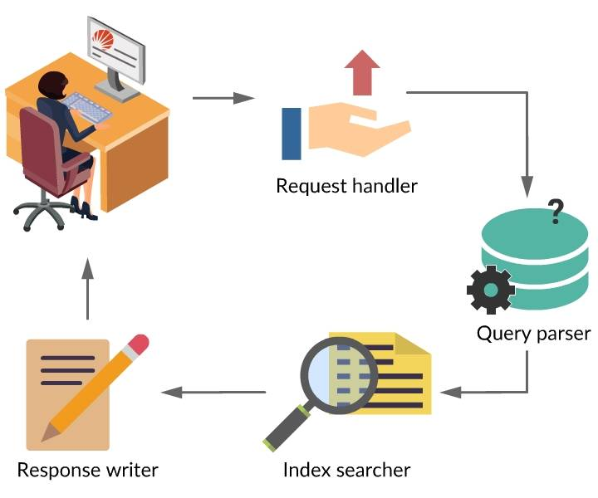

Searching is the process of consulting the search index and retrieving the most related documents that match the query.
The following steps help you understand the searching process in Solr.
- The query that is searched is processed by the Request Handler.
- Request handler calls a query parser to process a search query.
- Query parser interprets the terms and parameters of a query and passes the query object to the Index Searcher.
- Index searcher searches through the documents and returns the top documents that match the query to the Response Writer.
- Response writer formats the response and manages the final presentation of the Query Response.

Query Parameters in Solr
The data that is stored in the Solr Index can be queried by using the query parameters. The following are the common query parameters available in Solr.
- q: This is the important query parameter of Apache Solr, with which you can retrieve the stored documents. If you want to retrieve the whole document from the index, you need to pass the symbol ":" as a value to the q parameter and execute the query. In the same way, if the particular document is to be retrieved, you need to pass the name-value pair of that document as a value to the query parameter.
- fq: This parameter represents the filter query, which filters the documents and displays only those that match the query.
- Start: The starting offset for a page results is represented by the start parameter. The default value is 0.
- rows: The number of documents to be retrieved per page are specified by rows parameter. the default value is 10.
- sort: The query results are sorted by using sort parameter. It specifies the list of fields separated by commas.
- fl: If you want to get the specific fields in the resulted documents, you need to pass the required field list to the fl parameter.
- wt: This parameter represents the type of the response writer we wanted to view the result.
Single and multiple wildcard searches are supported by Solr standard query parser. Wildcard characters are applied only to the single terms.

Single character wildcard search type:
This type matches only a single character. The special character for this type is "?".
- Example: The search string ?ent would match both rent and tent.

Multiple character wildcard search type:
This type matches zero or more sequential characters. The special character for this type is "*".
- Example: The wildcard search for the string pain* would match paint, painter, painting.

Fuzzy Search
Based on the edit distance algorithm, the Fuzzy search is supported by the standard query parser of Solr. The fuzzy search identifies those terms that are similar to the queried term. They need not be exactly matched with the searched term.
The fuzzy search is performed by adding the tilde symbol "~" at the end of every single word.
- Example:
  - roam~
The above term will match the words like roams, foam, foams.

Proximity Search
A proximity search looks for those terms that are within a definite distance from one another.
Proximity search is performed by adding a tilde "~" character and a numeric value at the end of a search phrase.
Example:
“jakarta apache”~10
"apache" and "jakarta" within ten words of each other in a document can be searched by using the above search.

Range Search
In Range search, range values are specified for the fields. The query matches only those documents that are within the specified field range.
Range search is performed for both the numeric and non-numeric fields.
Example 1:
popularity:[22 TO 1000]
The above query matches all those documents that range between 22 and 1000, including 22 and 1000.
Example 2:
title:{Aida TO Carmen}
The above query matches those documents whose titles are in between Aida and Carmen, but not including Aida and Carmen.

Boosting
If you want the term to be more relevant while searching with the phrases, you need to boost the term. This type of searching is known as boosting.
Boosting can be done by adding the caret "^" symbol followed by boost factor, at the end of the term you are searching.
Example:
Health^4 insurance
The above query makes the term "health" more relevant in all documents.
The default value of the boost factor is 1, and it should always be positive.

ReRank Query Parser
The rerank parser wraps a query specified by an local parameter, along with additional parameters indicating how many documents should be re-ranked, and how the final scores should be computed:
Parameter | Default | Description
reRankQuery | (Mandatory) | The query string for your complex ranking query - in most cases a variable will be used to refer to another request parameter.
reRankDocs | 200 | The number of top N documents from the original query that should be re-ranked. This number will be treated as a minimum, and may be increased internally automatically in order to rank enough documents to satisfy the query (ie: start+rows)
reRankWeight | 2.0 | A multiplicative factor that will be applied to the score from the reRankQuery for each of the top matching documents, before that score is added to the original score
In the example below, the top 1000 documents matching the query "greetings" will be re-ranked using the query "(hi hello hey hiya)". The resulting scores for each of those 1000 documents will be 3 times their score from the "(hi hello hey hiya)", plus the score from the original "greetings" query:
q=greetings&rq={!rerank reRankQuery=$rqq reRankDocs=1000 reRankWeight=3}&rqq=(hi+hello+hey+hiya)
If a document matches the original query, but does not match the re-ranking query, the document’s original score will remain.

http://solrv5.intranet.mckinsey.com/solr/microBlogs/select?q=*%3A*&fq=createdAt%3A%5BNOW%2FDAY-90DAYS+TO+NOW%2FDAY%2B1DAY%5D&sort=likeCount+desc&rows=100&fl=bloggerName+personId+likeCount&wt=csv&indent=true

